Task:
- Define the ‘adopted user’ as a user who has logged into the product on three separate days in at least one seven day period.
- Identify which factors predict future user adoption.

Approach:
- Add ‘day’ column in engagement dataset and define the adopted users through:

adopted = engagement.groupby("user_id").apply(
lambda df: any(
df.drop_duplicates(subset="day")
.sort_values("day")["day"]
.diff(periods=2)
<= timedelta(days=7)
)
)

- Add ‘adopted_users’ to both engagement and users dataset, where adopted_users is 1, and nonadopted users is 0.
- Change users['last_session_creation_time'] ,users['creation_time'] dtype from object to datetime.
- Add users['recorded'] in feature engineering. It shows adopted users have significant higher recorded time.
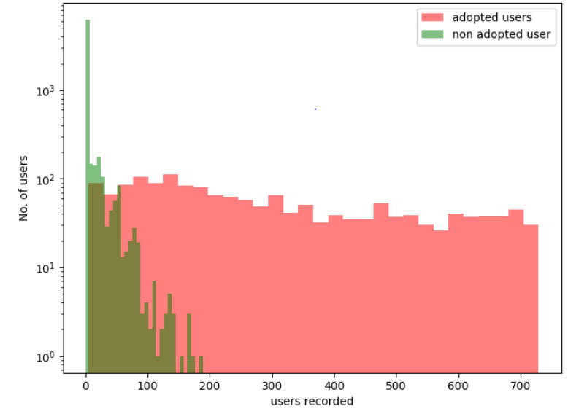

- The “creation_source” shows more nonadopted_users. The guest_invite and org_invite have higher relative adopted users than others. 'opted_in_to_mailing_list' and 'enabled_for_marketing_drip' don’t show significant contribution for adoted users.
- Randomforest classification model which accuracy can reach to 0.95 (or 95%) shows the most important feature for predict adopted users is ‘recorded’.

